 |   2nd International Conference  on  Integrated Transport for Sustainable Mobility  (3-4 February 2023, Kathmandu, Nepal) | 
Possibility of Bridge and Fly over-Bridge over in
Naghdunga Naubise Section
Susan Timsina
Student, Pulchowk Engineering Campus, Lalitpur, Nepal
Abstract
Combination of bridge and flyover which we termed "Bridge and fly over-Bridge over" is the project that we thought to be one of the national mega project one day. As our country is country with geographic diversity, our upper regions are hilly and mountainous region with small to high hills and mountains where development is very difficult due to lack of transportation means and due to dangerous small roads accessing that place on hills. As We see and listen various accidents in hilly region due to condition of roads (i.e. narrow and not properly graveled) which is risking many individual’s lives. Due to lack of place in hill for expansion roads are narrow thus by considering these difficulties in construction of roads in hilly area by cutting hills causing risk of landslide and increase in traffic problems in hilly roads (considering Thankot- Naubise road). The urban areas are suffering from unmaintained externalities such as excessive travel time, unnecessary fuel consumption and even serious economic loss due extraordinary growth in automobile traffic (i.e. motorcycle and car), and as consequence of automobile ownership and usage have continued rapid growth into recent days. We thought and learned of an idea in order to minimize risks of landslide and proper flow of traffic in that region. In this project we thought of an idea to build bridge over respect to curvature of hills through which it passes by providing the support (i.e. column to support the beam whose height is maintained per terrain slope). We believed that this project will definitely be the best project to develop expressway reduce the meandering roads in hill to straight, reduce distance of travel, reduce traffic problems that we face during travel to our village and so on. It is a concept of an integrated infrastructure based on the most innovative technologies adopted in order to smooth travel, control global air pollution due to traffic as well as water logging on road surfaces. These technologies can hence promote smooth transportation at the junction with reduced accident rates.
Keywords: Meandering; flyover;
- Introduction
Nepal is a mountainous country of geologically young mountains. Generally roads and other linear structures are laid along the steep hill slopes. These hill roads are also crossed by numbers of streams and rivers. Tribhuvan highway is also one of the major roads laid on the steep hill slopes, which joins the Capital City to the other parts of the country. Roads laid on such fragile geomorphology are vulnerable to various kinds of disasters. The roads section Nagadhunga - Naubise also experiences frequent slope failures, landslide, and road block. The landslide and blockage of the road especially during monsoon season have frequently blocked the traffic movement with numbers of accidents. Landslides have always been a major hazard to the safety of people and their property. The fragile and young Himalayas with torrential monsoon, earth tremors and environmental degradation have together increased occurrence of landslide in Nepal. This road is a part of Asian Highway (AH-42) and is the most important road corridor in Nepal. The road section from Mugling to Kathmandu lies on geologically difficult and fragile hilly and mountainous terrain. Since the average daily traffic in this route is comparatively very high, the present road condition and available facilities are not sufficient to provide the efficient services. Thus, the timely improvement of this road is considered the most important. "Bridge Over - Mega Project" is project that we dreamed off that may come into practice in near future in the country. We basically consider Naghdunga Naubise road area (the entrance for both eastern and western Nepal) which usually faces high traffic problems & various other problems caused by landslide during rainy seasons. We usually are also the victim of the bad condition of the road which are usually being faced during the transportation done for various purpose. As we all know that the tunnel fast back is also under construction in that area from Chandragiri (Naghdhunga Tunnel, East portal) to Naghdhunga Tunnel West portal, which we thought to be our start point of this project. Continuing the tunnel fast track, we dreamt of the “bridge over” as a part of that expressway that we hoped to reduce the passage of road transport from about 24km to 5 km saving most of the travelling time. We from this project hope to standardize the level of transportation in country.
1.1 Concept of bridge
A bridge is a structure built to span a physical obstacle (such as a body of water, valley, road, or rail) without blocking the way underneath. It is constructed for the purpose of providing passage over the obstacle, which is usually something that is otherwise difficult or impossible to cross.

1.2 Concept of fly over
A Flyover is a bridge constructed along an intersecting highway over an at-grade intersection. Flyover is one of the methods for solving traffic problems at-grade junctions on a highway including capacity, congestion, long delay and queue length.

  - Concept of bridge over hills
The concept of the Over bridge is the combination of the highway and the bridge situated at the altitude connecting the one hills over the another hills. It is a kind of overpass but connecting between the hills.

Reference Area

Nagdhunga - Naubise Road:
The Nagdhunga- Naubise Road is part of TH, which is a national highway as per DoR classification with road reference No. H 02. This road was initially constructed in 1956 and then rehabilitated in 1997. The salient features of this existing section
Of road are mentioned below:

Name of Road : Nagdhunga — Naubise Road
Road Reference No : H 02
Link Code
Nagdhunga to Peepalmod : H 0214
Peepalmod to Naubise : H0213
Length : 12.5 Km
Carriageway Width : 5.5 to 7.5 m
Shoulder Width : 0.5 m
Formation Width : 7.5 - 9.5 m
Minimum Radius of
Horizontal Curve : 17 m
Number of Horizontal Curves : 169
Number Curves with R=or<25m : 33
Maximum Gradient : 10.19% at Km 0+289;
10.34% at Km 1+512;
10.31% at Km 2+451
Grade more than 7 % : At 20 locations
Pavement Composition : Sub-base 20 cm
Base 18-25 cm and
Bituminous Layer 5 - 10 cm
Condition of Road Pavement : Fair to Poor; IRI >7; SDI 1.7— 3.
Number of Bridges : 2 No's, Total Length: 45 m
Number of Culverts
Hume Pipe : 52
Slab Culvert : 8

1.4 Problems of transportation in this area
- Landslides and blockage of the road especially during monsoon season.
- Narrow roads and lack of spaces for expansion.
- Lack of proper hill irrigation system.
- Long meandering roads.
- Long traffic jams and congestion.
- Geologically difficult and fragile hilly and mountainous terrain.
- Numbers of accidents

1.5 Analysis of Alternatives
An analysis of alternatives was based on safety considerations, geometric improvements with current traffic and future projections, and social and environmental impacts. Six alternatives were proposed in the ESIA:
- The first alternative considered the improvement of existing road to a 2-lane standard with curve improvement, an additional 2 bridges, and expansion to a 4- lane in urban areas;
The second alternative was to improve existing road to a 2-lane standard with curve improvement, a tunnel bypass and 4-lanes in selected urban areas
- The third alternative included improvement of the existing road to a 2-lane standard with curve improvement, construction of a new 2-lane road alignment from Sisnekhola to Dharke, and expansion to a 4-lane in selected urban areas
- The fourth alternative included minor improvements in the 2-lane standard, construction of new lane from Sisnekhola to Dharke, construction of 4-lane road from Dharke to Benighat, improvement of the existing road from Benighat to Mugling into two lanes, and a 2-lane new alignment on right bank of Trishuli River from Benighat to Kurintar.
- The fifth alternative proposed the improvement of the existing road from Nagdhunga to Dharke into a 2-lane standard with curve improvement, a tunnel bypass and construction of a new 2-lane new alignment from Sisnekhola-Dharke, construction of a 4-lane road from Dharke to Benighat, improvement of the existing road from Benighat to Mugling into 2-lane, and 2-lane new alignment on the right bank of Trishuli River from Benighat to Kurintar.
- The sixth alternative included improvement of the NNM Road into a 2-lane Asian Highway Standard including two bypass sections.

1.6 Why bridge over can be modern solution for problem
- It reduces risk of damage caused by landslide in road transport.
- It reduces the travel distance by shortening long meandering route to straight road ways.
- It reduces accident that occurs due to narrow & un-graveled road due to lack of area for expansion in content of Nepal.
- It reduces traffic problem faced in that area.
- It smoothens travel of vehicles carrying vegetables, petroleum products and other important goods.

1.7 Objectives of project
- To construct the first over Bridge Over in County.
- To standardize level of transportation in Country.
- To solve the traffic problem faced in that area.
- To reduce the damage caused by landslide in transportation sector.
- Reduction of travel distance.

- Description of project selected

2.1 Idea of project

To overcome all the difficulties in development of transportation in hilly region of country the major idea of our project is to construct an overhead flyover bridges connecting various hills as per curvature of hills taking elevation as reference. The concept of the Over bridge is the combination of the highway and the bridge situated at the altitude connecting the one hills over the another hills. It is a kind of overpass but connecting between the hills.

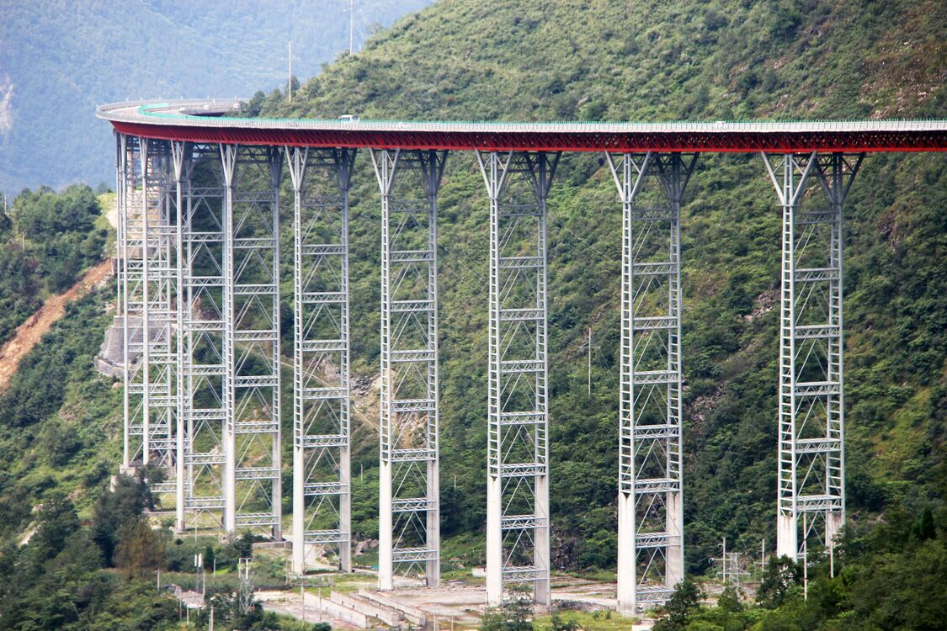

Fig 1: Sample of bridge type

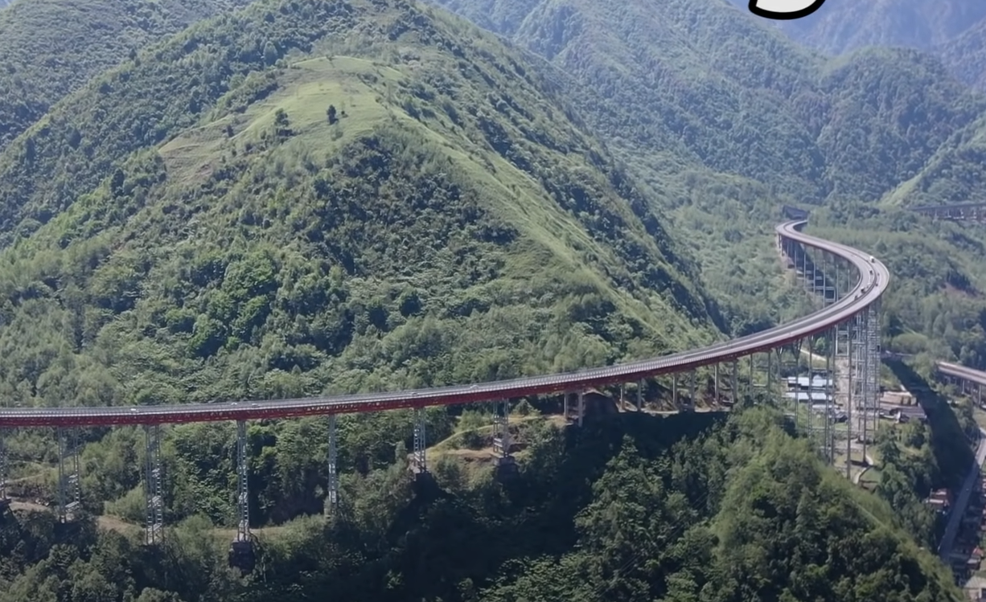

Fig 2: Model of bridge

2.2 Location (Reason for selection of that location)

We consider the Tribhuwan highway (Naghdunga - Naubise section) for this project. It is the main transit point to enter Kathmandu as all the night buses, vegetables trucks as well as other goods carrying vehicles entering Kathmandu enter through this transit. Almost about 20 thousand vehicles passes daily through this section. It is one of the most crowded section of the highway. As this is the hilly section of Tribhuwan highway containing about the hills of height 5000 to 7000 feet so it is difficult to construct the road as well as travel through it as this section is a 2 lane highway where usually passes in high speed. Due to the sharp turn bending in the section it usually faces high accident chances. Almost being constructed as the 2 lane highway due to landslides, debris flow in this area the width of the road have been decreased. Due to regular landslide this section usually faces a long traffic blockage which may last for 2-3 hours to several days.

In the terms of expansion of the width of this section, the chances of landslides are increasing day to day and the beauty of the section is degraded. Due to the regular landslides, there is still investment and maintenance cost for the damaged of the road which is very high. As many retaining wall is still needed to be constructed for the safe travelling in this highway.

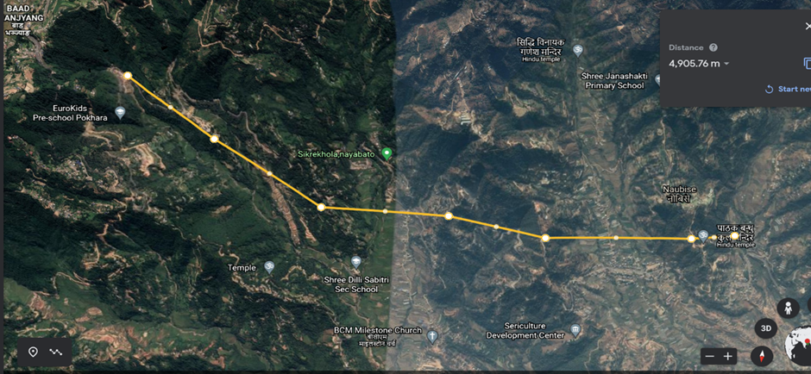
Fig 3-4: location map
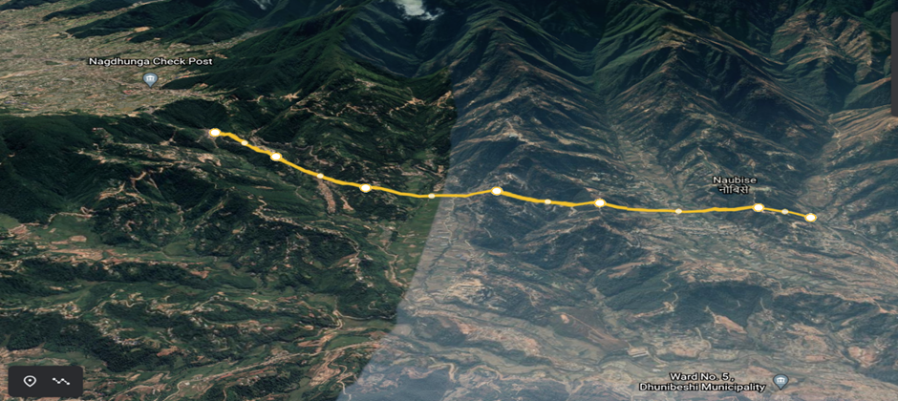

- Analysis

3.1 Contour analysis

This section of our project area contains hills ranging from 1400 to 1600 meters elevations. Contour lines ranges from 1000 meter bottom trenches to 1600 meters high hills elevation from sea level. It represents elevation from 3000 ft to 5000 ft.

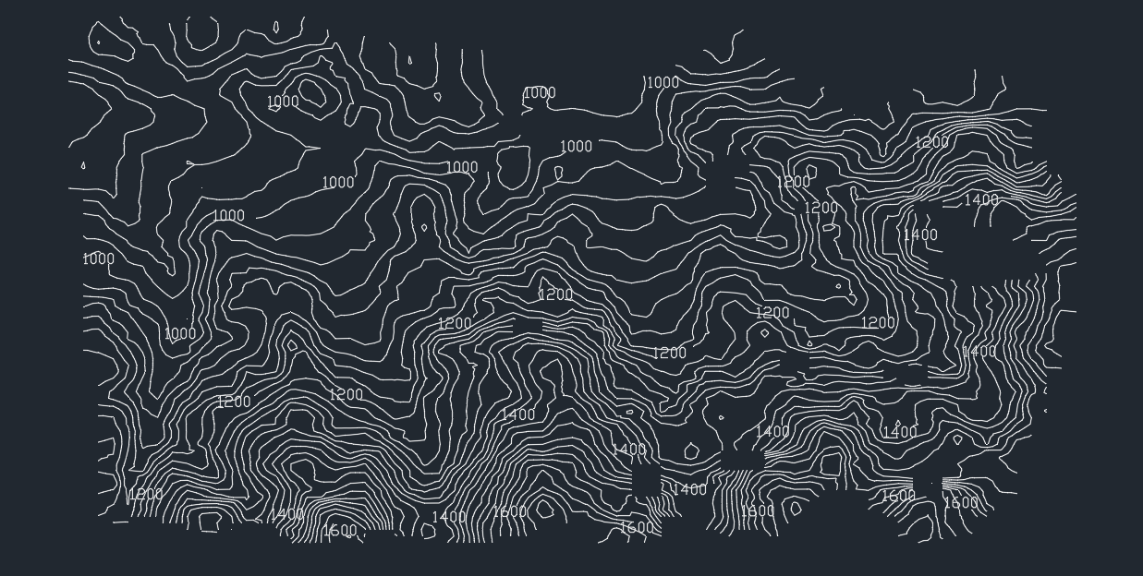

Fig 5: Contour map of area
3.2 Gradient analysis

Desired starting elevation = 1295m
Approximate Elevation difference = 372m
From analysis of contour and elevation difference between start point and end point assumed for project approximate gradient is found to be 7.44% which is fine for design and construction of bridges in hills.

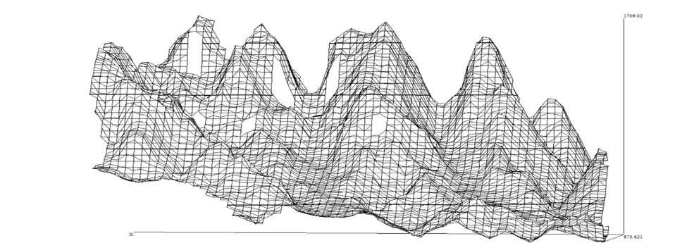

Fig 6: 3D representation of area
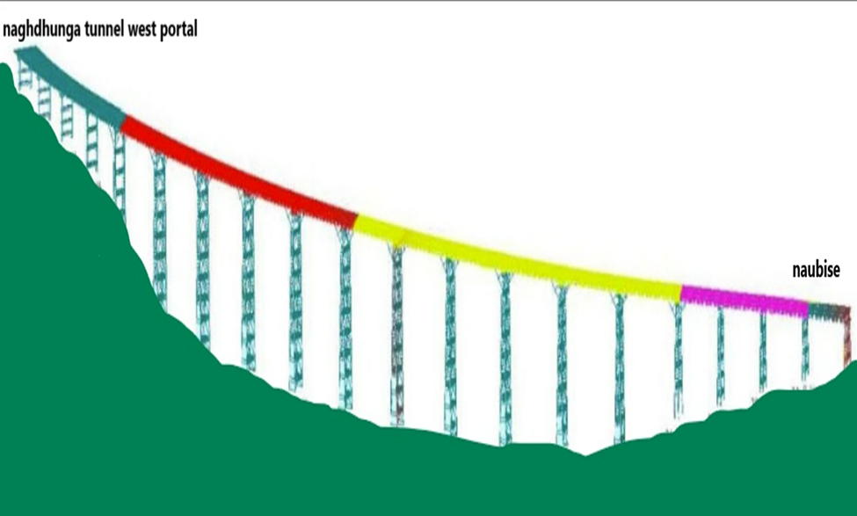

Fig 7: general representation of gradient

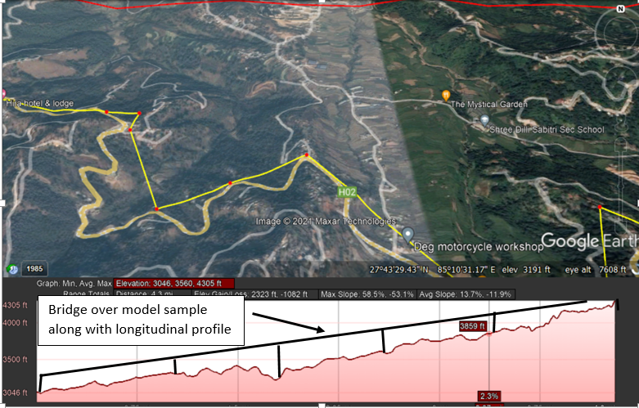

Fig 8: Bridge over model sample along with longitudinal profile

3.3 Land use and Land cover change of area
Non-irrigated sloped terraces and forest-covered slopes are the most found land use type in the study area as shown in Table 1. Lowest area includes sandy area. Figure 9 shows the Land Use map of the study area.
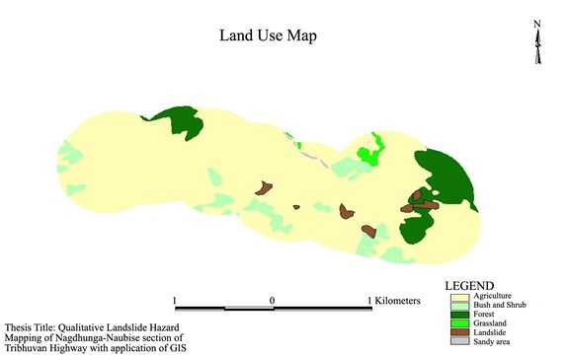
Fig 9: Land use map of area
Table 1: Data from land use map
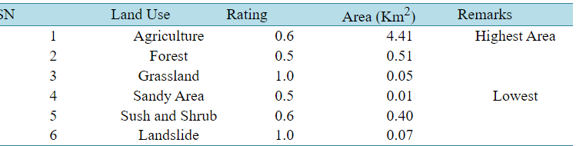

3.4 Distance analysis

Total length of road in that area = 12.4km
Total span of bridge to be built= 4.9km

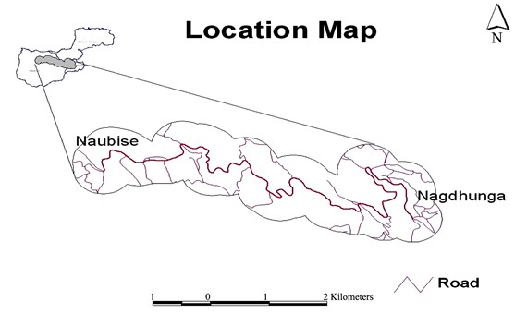

Fig 10: Location map

3.5 Soil and Geology analysis

The entire length of the designed site model runs over hills, valleys, and alluvial deposits in the midlands of the Lesser Himalayan Zone, which vary in altitude from 200 to 2000 m. Main rock types found in this area are schist, phyllite, gneiss, quartzite, granite, and limestone. This type of geology features is suitable for the construction of the flyover. The Kathmandu Geological Complex characterizes the geology of the study area. Figure shows the proportion of different geological compositions of the study area. From the Geological Map as shown in Table, the large portion of the study area falls 60% under Chandragiri Limestone, 20% under Sopyang formation and 12% under Colluviums. Chandragiri Limestone consists of light limestone, partly siliceous-argillaceous, fine-crystalline, echinoderms. Similarly, Sopyang Formation consists of slate with thin beds of limestone.
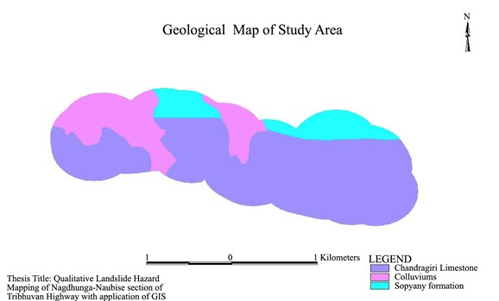

Fig 11: Geological map of study area

Table 2: Composition of soil formation
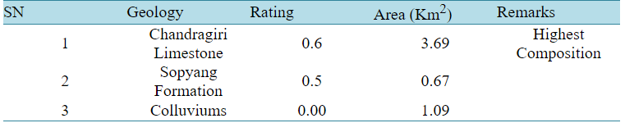

3.6 Landslide hazard mapping of study area

The final hazard map shows that in the areas with hazard potential class “low” with 32% portion, “Medium” is most found with a portion of 51% followed and “high” with the portion of 17%. The statistical analysis from the calculation of the landslide percentage per Km² in the area is 1.1 per Km² (highest), which is nearly equal to the value of Middle Mountain region as 1 landslide per Km², as suggested by Wagner, 1983. Due to the lack of important terrain information such as weathering effect, structural discontinuities, seismicity and hydrogeology were not included in the analysis. Rainfall is the main cause of failure, but it is not incorporated in the hazard rating due to the small area and the fact that it is very difficult to keep record of such variation within the small area.

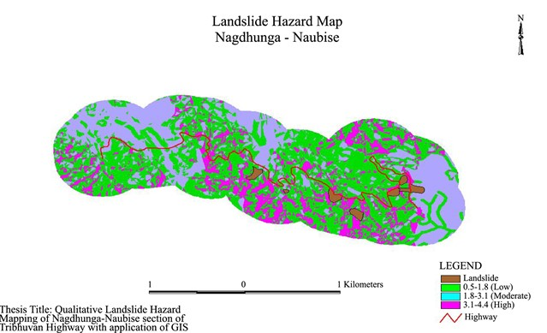

Fig 12: Landslide hazard map

Table 3: scale of failure potential
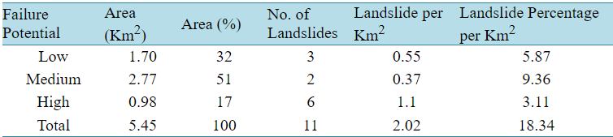

3.7 Traffic volume and composition
- Traffic volume at Nagdhunga section is increasing every year.
- Share of heavy vehicle shows very high rate accounting to 48% of total traffic.
- Neglecting no of small vehicles including motorbike, scooter, bicycle etc it is 10664 vehicles per day passing through to this section of highway.

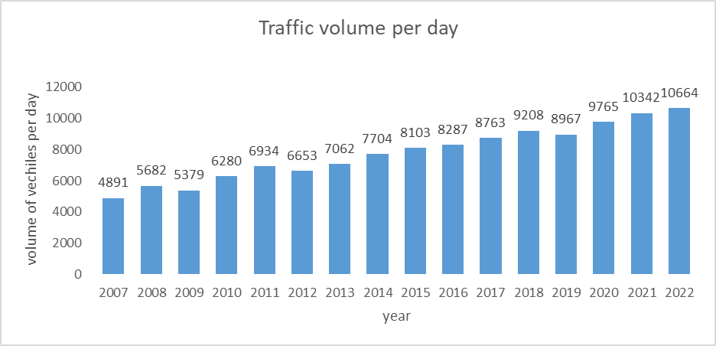

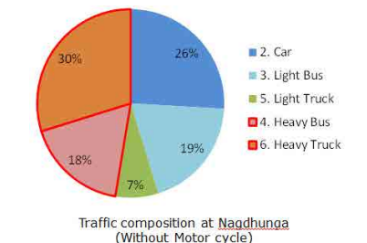

Fig 13-14: traffic volume pattern and traffic composition of area

3.8 Economic feasibility analysis

Total length of road in that area = 12.6km
Total span of bridge to be built= 4.9km
Total estimated expenses in construction of road of that fully developed road
Estimated cost for construction of 1 km road in plain area = 3-4crore per km

In case of hilly area
Estimated cost for cutting of hill and building road= 5-6crore per km
Estimated cost for full road length= 12.6 *5.5 = 69.3crore
Cost of construction of wall to prevent landslide in upward side of road= 3-4crore per km
Cost of construction of wall to prevent landslide downward side of road if necessary =50 lakh per km
Cost of construction of drainage in road in either side = 35 lakh per km Total expense in construction of road = 5.5+3.5+0.5+0.35 = 9.85crore per km
Assuming our pre constructed road in Naghdhunga - Naubise road area making it fully developed
Total expense in construction of 12.6 km road = 9.85*12.6 = 124.2crore
Total estimated expenses in construction of fully developed bridge = 45-55crore per km
Total expense in construction of 4.9 km bridge = 150*4.9 = 735crore (Our rough estimation)
(It can be more considering the type of bridge, type of soil and terrain in which the bridge is to be built)
Total differences in expected expenses = 735 - 177.3= 557.7crore

In long term consideration
Total reduction in length of travel = 12.6 - 4.9= 12.1 km
Total reduction in time of travel = indeterminate
Average no of vehicles travelling through that area = 18000 (including night buses, vegetable carriage trucks, bikes, cars, and so on)
Average saving of fuel considering all vehicles travelling through that area = 1.5ltrs per vehicles
Total saving of fuel by vehicles per day = 18000*1.5 = 24000ltrs
Present price of fuel = average of Rs 160 per liters
Total price of fuel saving per day = 24000*160 = Rs3840000
Taking only 5 year in consideration
Total saving of fuel = 5*3840000*365 =7008000000 = Rs 700.8crore in 5 years

3.9 Problems in conduction of project
- It is very expensive project with huge investment requirement.
- It requires heavy and modern developed technology for efficient operation.
- It requires highly skilled manpower, engineers for conduction of project.
- It requires high strength raw materials for construction.

In context of Nepal
- Lack of investment for projects
- Political instability
- Lack of interest of private sectors in national level of projects.
- Lack of skilled and talented man powers.
- Lack of technological development in country.

- Conclusion
As in this project we thought of an idea of constructing a bridge over we take the location of Naghdhunga Naubise area which connects all eastern and western parts of country taking already built 12.6 km road in that area which we planned to convert it into 4.9 km bridge over. As soil, geology, gradient, contour all analysis is suitable for construction of bridge over in this region. Estimation of the cost of construction was done. Considering 12.6 km road or 4.9 km bridge over to be built in that area we estimated construction cost referencing to Google data. Construction cost for road was estimated including excavation of road, gravelling, pitching of road, construction of drainage, construction of wall preventing landslide and so on. Also construction cost for this bridge span was found including foundation, bridge span and so on. The difference in investment was approximately found. Also by doing analysis on the benefit due to the construction of bridge over we estimated the saving of fuel of cost in that area with high transportation mobility thus looking long term importance and use of bridge over we can conclude that construction of bridge over is affordable and advantageous in that area.
Taking consideration of other hills we can construct the bridge over in order to solve transportation difficulty in various rural parts of country. As transportation mobility in that area may differ from what we assume the initial expenses can be recovered in long term use. Taking the consideration of low budget or investment capability of country we can ask for foreign aid or grant that can be easily recovered on long term use. Thus for standardization of transportation in country this bridge over construction can be the best idea. We believed that this project will definitely be the best project to develop expressway reduce the meandering roads in hill to straight, reduce distance of travel, reduce traffic problems that we face during travel to our village and so on. It is a concept of an integrated infrastructure based on the most innovative technologies adopted in order to smooth travel, control global air pollution due to traffic as well as water logging on road surfaces. These technologies can hence promote smooth transportation at the junction with reduced accident rates.

- References

- Final Report Preparatory Survey For Nagdhunga Tunnel Construction In Nepal (2014), Japan International Cooperation Agency (JICA), Kathmandu.
- Pandey, A.R. and Shahbodaghlou, Farzad. (2014) Landslide Hazard Mapping of Nagadhunga-Naubise Section of the Tribhuvan Highway in Nepal. Department of Civil, Architectural, and Environmental, Illinois Institute of Technology, Chicago, USA.
- Ministry of Home (2003) Annual Report. Kathmandu.
- Department of Water Induced Disaster Prevention, Government of Nepal (2004) Report of Photo Monitoring in Kathmandu-Naubise Road. Kathmandu.
- Development Cooperation Implementation Division (DCID), (2020) Improvement of Naghdhunga-Naubise-Mugling (NNM) Road Environmental and Social Impact Assessment (ESIA), Environment & Resource Management Consultant (P) Ltd, Kathmandu.
- GON (2017) Detailed Project Report of Kathmandu (Nagdhunga) - Naubise - Mugling Road and Bridges Nepal India Regional Trade and Transport Project (NIRTTP), Department of Roads Foreign Cooperation Branch, Ministry of Physical Infrastructure and Transport, Government of Nepal.
- Regmi, R.K. (2018) Assessment of Hydro-Meteorological Condition of Kathmandu (Nagdhunga)-Naubise-Mugling Road and Bridges. Institute of Engineering, Lalitpur
- DoR (2017). Feasibility study for improvement of Kathmandu (Nagdhunga)-Naubise Mugling Road and Bridges, Final Feasibility Report, Department of Roads Foreign Cooperation Branch, Ministry of Physical Infrastructure and Transport, Government of Nepal.

Corresponding author. Tel.: +977-9862425795 E-mail address: 075bce180.susan@pcampus.edu.np

